St Mark’s Prayer Garden
There for you to enjoy

You can find our Prayer Garden ‘behind’ the church, next to the Garden of Remembrance.
Opened in the summer of 2017, the garden offers a quiet and attractive space for prayer, relaxation and reflection.
The garden is set out in three zones, representing the Birth, Death and Resurrection of Jesus. The wide variety of plants filling the garden are all mentioned somewhere in the Bible. Signs will help you identify the plants and the references. See also the listing overleaf.
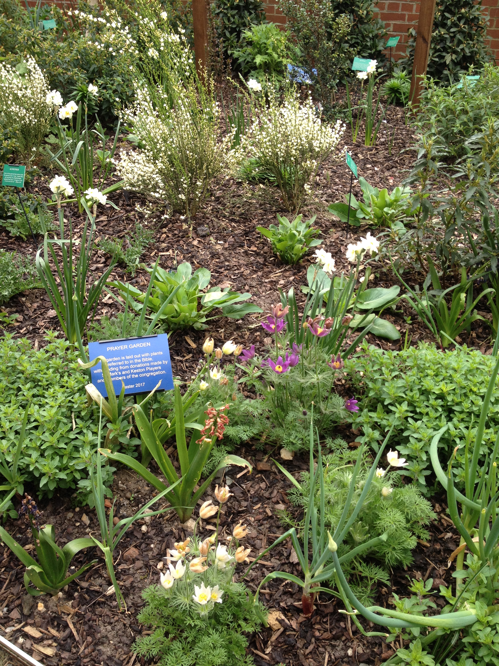
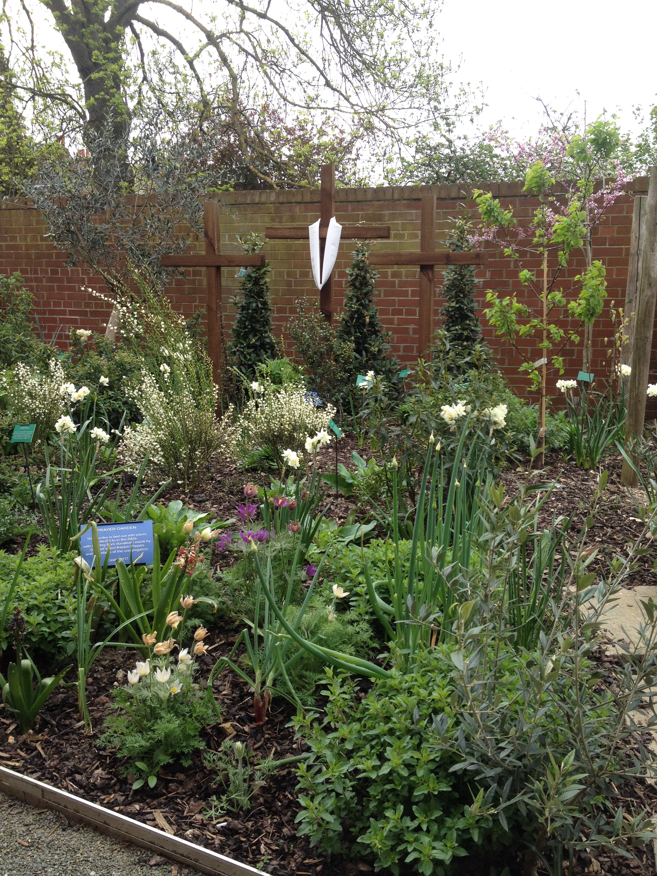
You may like to:
- simply sit and enjoy the peace and the plants
- meditate on the significance of the story of Jesus
- explore the Bible references and let God speak to you through them.
The Prayer Garden is there for you!
Biblical references to plants in the garden

Acanthus Judges 8:7; Isaiah 5:6, 7:23-25, 55:13; Ezekiel 2:6;
Ezekiel 28:24; Micah 7:4; Matthew 13:7; Luke 6:44
Bay tree possibly Psalm 37:35
Bean 2 Samuel 17:18; Ezekiel 4:9
Broom 1 Kings 19:4-5; Job 30:4; Psalm 120:4
Burning Bush cf. Exodus 3:1-6
Coriander Exodus 16:31
Cucumber Numbers 11:5; Isaiah 1:8; Jeremiah 10:5
Cumin, Dill Isaiah 25:25-27; Matthew 23:23
Garlic Numbers 11:5
Judas tree cf. Matthew 27:5
Leek Numbers 11:5
Lentil Genesis 25:34; 2 Samuel 17:28, 23:11; Ezekiel 4:9
Lily Song of Songs 2:1-2; Hosea 14:5; Matthew 6:28
Mint Matthew 23:23
Myrtle Isaiah 41:9, 55:13
Olive Genesis 8:11; Deuteronomy 24:20; 2 Samuel 15:30;
Psalm 52:8, Isaiah 24:13; Jeremiah 11:16; Zechariah
4:3-12; Mark 11:1, 13:3, 14:16; Romans 11:24
Onion Numbers 11:5
Oregano possibly 2 Kings 4:39
Palm Exodus 15:27; Leviticus 23:40; Psalm 92:12;
John 12:13; Revelation 7:9
Rock Rose cf. Genesis 37:45, 43:11; Numbers 11:7;
Matthew 2:11
Saffron Song of Songs 4:14
Thistle Genesis 3:18; Isaiah 34:13; Hosea 10:8;
Matthew 7:16; Hebrews 6:8
Vine Leviticus 19:10; Psalm 80:8; Isaiah 5:1-7; Jeremiah
2:21, 6:9, 8:13; Ezekiel 15:2-6, 17:6-8; Hosea 14:7;
Micah 4:4; John 15:1-5; Revelation 14:18

